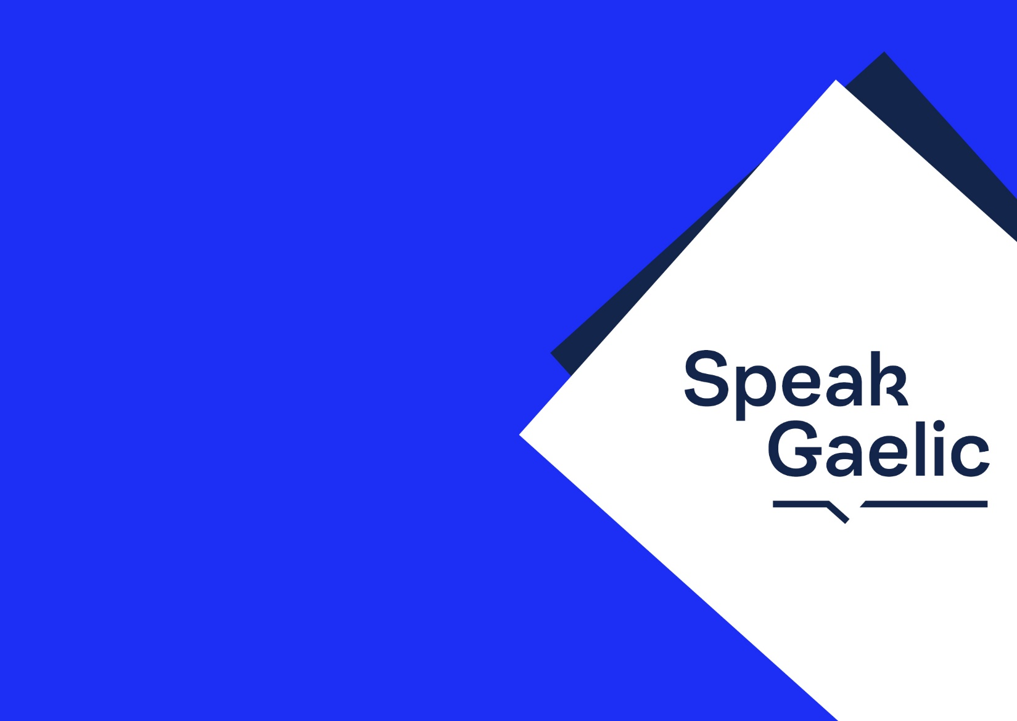
Gaelic Class
A1 - Inntrigeadh | Entry
Tuesday 7 – 8:30pm at ...
Classes start on the 30th of August.
If you are interested, please contact:
name@organisation.com
SpeakGaelic A1 is suitable for complete beginners.
The course covers practical every day topics and
will give you the confidence to talk a bit about
yourself, your family, work, and hobbies and
interests. The course materials can be
downloaded at:



www.speakgaelic.scot

